Creating and Working with an EC2 Instance

STEP-1:

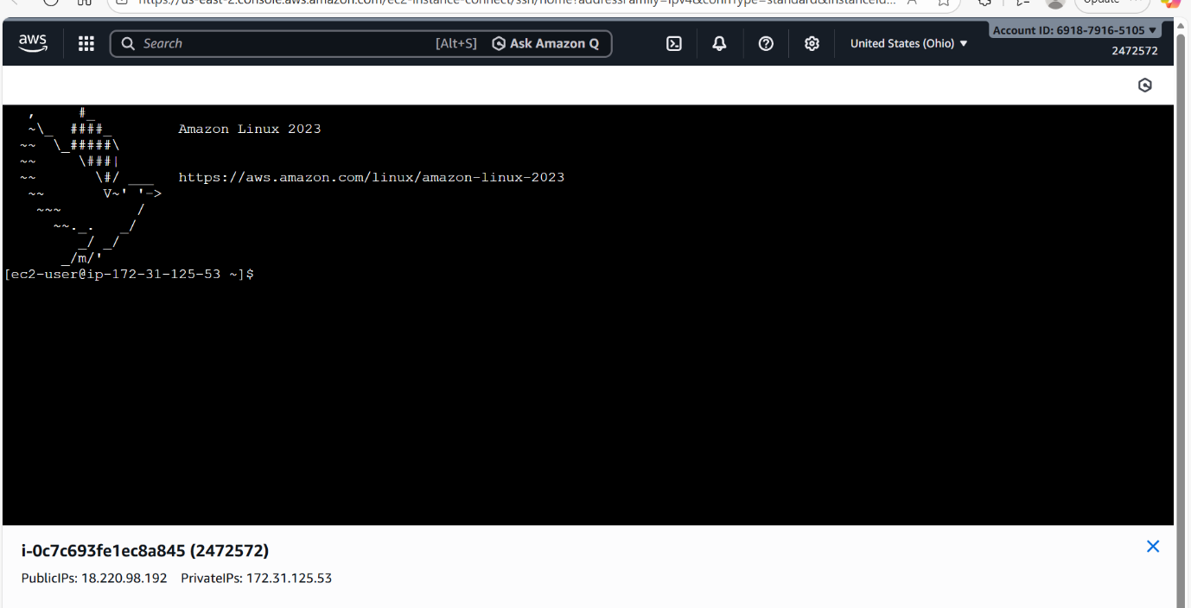

STEP-2:
